 

**Cybernetics Protector**

SOFTWARE REQUIREMENTS SPECIFICATION

[Version 1.0 -- January 28 2011]



**Team**



**Team Members:**

|  |  |
| --- | --- |
| Siddarth Jindal  Student, Part II, B Tech Computer Engineering  jindal.siddarth@gmail.com | Syed Wali Hamza  Student, Part II, B Tech Computer Engineering  talk2s.wali@gmail.com |

Kajal Roy Piyush Kapoor Student, Part II, B Tech Computer Engineering Student, Part II, B Tech Computer Engineering

kajalroy.bhu@gmail.com kajalroy.bhu@gmail.com

**Project Guide:**

Assistant Professor Ravi Shankar Singh

Department of Computer Engineering

Institute of Technology Banaras Hindu University, Varanasi

Uttar Pradesh, India

|  |
| --- |
| Contents |

|  |  |  |
| --- | --- | --- |
| **Section** | **Title** | **Page** |
|  |  |  |
| **1** | **Introduction** |  |
| 1.1 | Purpose | 3 |
| 1.2 | Scope | 3 |
| 1.3 | Abbreviations | 4 |
| 1.4 | Methodology | 5 |
| 1.5 | Tools & Technologies | 6 |
| 1.6 | References | 6 |
| 1.7 | Overview | 6 |
|  |  |  |
| **2** | **Overall Description** |  |
| 2.1 | Product Perspective | 7 |
| 2.2 | Software Interface | 7 |
| 2.3 | Hardware Interface | 8 |
| 2.4 | Communication Interface | 8 |
| 2.5 | User Characteristics | 8 |
| 2.6 | Constraints | 8 |
| 2.7 | Product Functions | 9 |
| 2.8 | Use Case Model Survey | 10 |
| 2.9 | Architecture Diagram | 13 |
| 2.10 | Database Schema | 14 |
| 2.11 | Assumptions & Dependencies | 14 |
|  |  |  |
| **3** | **Specific Requirements** |  |
| 3.1 | Use Case Reports | 15 |
| 3.1.1 | Administrator | 15 |
| 3.1.2 | Supervisor | 25 |
| 3.1.3 | Moderator | 36 |
| 3.1.4 | Consumer | 45 |
| 3.1.5 | Common to all Users | 56 |
| 3.2 | Supplementary Requirements | 65 |
|  |  |  |
| **4** | **Appendices** |  |
| 4.1 | Acknowledgments | 66 |
|  |  |  |

|  |
| --- |
| 1. Introduction |

* 1. **Purpose**

The Secret Intelligence Agency has always used undercover agents to solve complex cases and dismantle criminal organizations. We are conceptualizing this software as a solution so that Secret Intelligence Agencies and their agents can communicate through this Software for the exchange of evidences in a secure way.

* 1. **Scope**

**1.2.1 Functional Requirements**

**Secret Agency’s Chief:**

* + Chief should be able to create/edit/view Agent’s profile
  + Appointing of Agent to a particular case.
  + Secure retrieval of evidences received from Agent.
  + Access to Data Base logs.
  + Should be able to trace Agent’s location (using IP addresses)
  + Generate Reports
  + Ability to store data with history (archive cases).
  + Ability to create Digital Signature certificates.

**Agent:**

* Able to view case details.
* Should be able to encrypt & upload evidence or data to Data Base.
* Able to view resources from ministry or chief.
* Generate Report.
* Should be able to view the dynamic map of anywhere in the world.

**Defence Ministry:**

* Should be able to send resources to Secret Agency.
* Receive reports
* Ability to assign cases to the Agency.

**Citizen:**

* Ability to see Success Stories.
* Chat assistance from Intelligence Agency.
* Ability to apply for a job in Secret Intelligence Agency.
* Ability to give tips & suggestion.

**1.2.2 Non-functional Requirements**

* Secure access of confidential data (user’s details). SSL can be used.
* 24 X 7 availability
* Better component design to get better performance at peak time
* Flexible service based architecture will be highly desirable for future extension
  1. **Abbreviations**
* **PDF :** Portable Document Format is widely used industry standard for documents
* **XLS :** Microsoft Excel 2007 Format for spreadsheets
* **PNG :** Portable Network Graphics is a bitmapped image format that employs lossless data compression
* **JPEG :** Joint Photographers Expert Group format is a commonly used method of lossy compression for digital photography
* **JSON :** JavaScript Object Notation is a lightweight data-interchange format
* **HTML**: Hypertext Mark-up Language is a mark-up language used to design static web pages
* **XML**: Extensible Mark-up Language is a text based standard for storage and exchange of structured information
* **UML** : Unified Modelling Language is an industry standard for graphical representation of software modelling results for requirements and design phases of software engineering
* **EJB**: Enterprise Java Beans
* **JSP**: JavaServer Pages is a server side technology for producing dynamic web pages
* **J2EE**: Java 2 Enterprise Edition is a programming platform— part of the Java Platform—for developing and running distributed multitier architecture Java applications, based largely on modular software components running on an application server
* **DB2**: DB2 Database is the database management system that delivers a flexible and cost-effective database platform to build robust on demand business applications
* **WASCE**: WebSphere Application Server Community Edition is an application server that runs business applications and supports the J2EE and web services standards
* **RSA** : Rational Software Architect is a modelling IDE used to generate UML diagrams among other uses
* **HTTP**: Hypertext Transfer Protocol is a transaction oriented client/server protocol between web browser & a Web Server
* **HTTPS**: Secure Hypertext Transfer Protocol is a HTTP over SSL (secure socket layer)
* **TCP/IP**: Transmission Control Protocol/Internet Protocol, the suite of communication protocols used to connect hosts on the Internet. TCP/IP uses several protocols, the two main ones being TCP and IP
  1. **Methodology**

The Rational Unified Process (RUP) is a software process product, originally developed by Rational Software, which was acquired by IBM in February 2003. The product includes a hyperlinked knowledge base with sample artefacts and detailed descriptions for many different types of activities. RUP is included in the IBM Rational Method Composer (RMC) product which allows customization of the process.

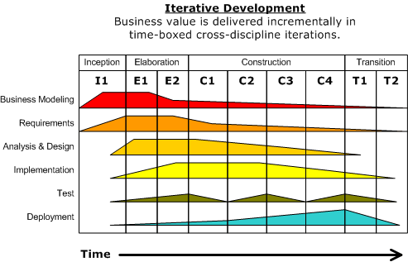

Combining the experience base of companies led to the articulation of six *best practices* for modern software engineering:

* Develop iteratively, with risk as the primary iteration driver
* Manage requirements
* Employ a component-based architecture
* Model software visually
* Continuously verify quality
* Control changes

These best practices both drove the development of Rational's products, and were used by Rational's field teams to help customers improve the quality and predictability of their software development efforts

* 1. **Tools & Technologies**
* **Java EE** : Application Architecture
* **DB2 :** Database Server
* **WASCE :** Application Server
* **jQuery :** JavaScript Library
* **RSA :** Design Tool
* **Eclipse :** Development Environment
* **Linux :** Operating System
  1. **References**
* IEEE SRS Format
* Problem Definition (Provided by IBM)
* IBM TGMC Sample SRS
* UML Applied-Object Oriented Analysis and Design using UML [Ariadne training UK]
* Wikipedia <<http://www.wikipedia.com>>
* For homepage Design <<http://www.mayfielddigital.co.uk/blog/web-round-up/best-responsive-web-design-examples-and-resources>>
* For Digital Signatures and TLS concepts <http://computer.howstuffworks.com/digital-signature.htm>
* Software Engineering 7 E, Ian Sommerville
* Java SE6 Documentation
* Beginning Java EE 5 from Novice to Professional, Kevin Mukhar & Chris Zelenak
* IBM developerWorks <<https://www.ibm.com/developerworks>>
  1. **Overview**

SRS will include two sections:

* Overall Description will describe major components of the system, interconnection and external interfaces.
* Specific Requirements will describe the functions of Secret Agency’s Chief , Agent , Defence Ministry and Citizen , their role in the system , their privileges and constraints.

|  |
| --- |
| 1. Overall Description |

* 1. **Product Perspective**

Database Server

[IBM DB2]

Application Server

[IBM WASCE]

Client Browser

[jQuery, XHTML, CSS]

JSON / HTTP

* The web pages [XHTML] are present to provide the user interface on user client side in the form of jQuery Templates. Communication between user and server is provided through JSON data over HTTP/HTTPS protocols.
* On the server side web server is for Controller Servlets and Java Services interact with Database server for storing the information.

* 1. **Software Interface**

Client on Internet: Web Browser (Any Latest), Operating System (any)

Application Server: WASCE v3.0, Operating System (any)

Database Server: DB2, Operating System (any)

Development End: Eclipse (Java EE, Java, Servlets, JSP), OS (Linux)

Buisness Logic(EJB 3.0)

DB2, OS (Linux)

WASCE v3.0 Application Server, OS (Linux)

* 1. **Hardware Interface**

|  |  |  |  |
| --- | --- | --- | --- |
| **Application** | **Processor** | **RAM** | **Disk Space** |
| **Client Side** | | | |
| Any Modern Web Browser | Intel Pentium IV or AMD | >256MB | >100MB |
| **Server Side** | | | |
| Web Sphere Application server v3.0.0.0 | Intel Pentium IV or AMD | >512GB | >1GB |
| DB2 v9.7.4 | Intel Pentium IV or AMD | >512GB | >2GB |

* 1. **Communication Interface**
* Client on Internet will be using JSON transport over HTTP / HTTPS protocol
* AJAX request-response shall be the usual medium of client-server interactions
  1. **User Characteristics**
* Every user should be comfortable of working with computer and internet browsing
* He must have basic knowledge of English
* He can access this site through mobile as well as computer
  1. **Constraints**
* GUI is only in English.
* This system is working for single server.
* Limited to HTTP/HTTPS.
  1. **Product Functions**
* **CASES AND INTELLIGENCE**
  + **Assignment of Cases :** This module shall support assignment of cases to the agents and keeping a track of their progress.
  + **Storing Cases :** This module shall provide functions for storing cases in a data repository , archiving them along with the supported documents and intelligence.
  + **Resource Flow :** This module shall control the flow of resources viz. documents and intelligence between ministry , security agency and agents in an encrypted form .
  + **Generation of Reports :** This module shall deal with the generation of reports by the agents , chief and further publishment of success stories by the ministry for the citizens.
* **MAPS AND LOCATION**
  + **View Map :** This module provides support for viewing of the map by the agent and finding a place for a given latitude and longitude using Google’s map api.
  + **Get Location :**  This module provides functionalities to get the location of the agent from his last signIn ip address for the chief and storing it in a data repository.
  + **Mark Locations :**This module supports marking locations on a map for convenience and other supported functionalities
* **CHAT AND COMMUNICATE**
  + **Chatting :** This is an integrated function that would provide citizens an ability to chat concerned people from intelligence wing of the defence ministry.
  1. **Use Case Model Survey**

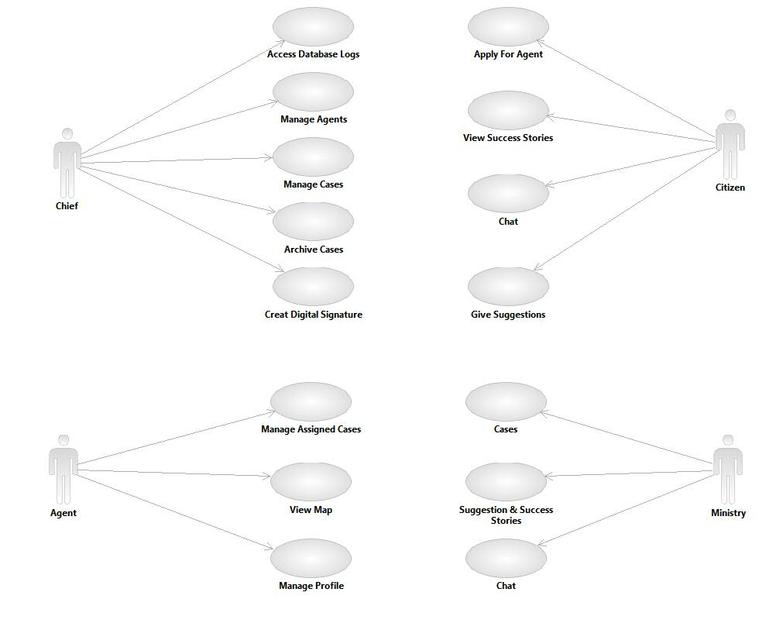

**USE CASE DIAGRAM**

* **CHEIF**

The Chief is responsible for managing agents, cases , creating digital signatures and database logging

* **Manage Cases**

The Chief shall appoint agents to cases depending on the agent’s past history and experitse ,retrieve encypted evidences from the agents , generate reports on the progress of a case and provide agents with the resources and intelligence for a case .

* **Manage Agents**

The Chief is responsible for appointment of citizens as agents depending on their eligiblity and application ,edit agent’s profile , view agents profile , get the location of an agent for the last signin ip address .

* **Access Database Logs**

The Chief can view the database logs and manage database security by granting agents rights over certain resources , and revoking privilege.

* **Archive Cases**

The Chief can store the cases , whether solved or unsolved in a data repository

along with all the supporting documents and intelligence.

* **Create Digital Signatures**

The Chief can create digital signatures with a private key to maintain authencity of documents , resources and reports .

* **AGENT**

The Agent can manage cases , view map and manage his profile.

* **Manage Cases**

The Agent receive the case details , related resources which may assist him to investigate the case , further he can encypt an upload the found evidences and generate reports.

* **View Map**

The Agent will have an access to a dynamic map made available to him using the Google map api where he can locate any place by its latitude and longitude, mark places and get his location.

* **Manage Profile**

The Agent can manage his profile, boast about his accomplishments and keep a track of the cases assigned to him.

* **DEFENCE MINISTRY**

The Defence Minister can deal with cases, publish reports and its intelligence wing can chat with agents.

* **Manage Cases & Resources**

The Minister can assign cases to secret agency along with the available details and related resources .

* **Receive & Publish Reports**

The Minister can receive reports from the secret agency and publish success stories .

* **Chat**

The intelligence wing of the defence ministry can chat with citizens .

* **CITIZEN**

The Citizen is any user who visits the site , can view success stories , apply for the post of an agent and chat with the inteligence department and give suggestion and tips.

* **Application**

The citizen can apply for the post of an agent filling a form with all the required information, this application goes to the security agency chief for approval in a secret way so that the identity of the citizen can be kept a secret.

* **View Success Stories**

The citizen can view success stories published by the ministry .

* **Give Suggestion & Tips**

The citizen can give suggestion and tips to the defence ministry which may be published on the site along with the name of concerned person if found useful.

* **Chat**

The citizen can chat with the inteligence department ,the ip address of the citizen, etc. will be stored by the intelligence wing of the defence department for security purposes.

* 1. **Architecture Diagram**

VIEW (Client)

XHTML CSS JSP

jQuery Templates

CONTROLLER (Server)

Controlling Servlet

JSP / JSON Engine

Dispatcher Servlet

Java Workflows

JDBC Driver

Entity Beans

Session Beans



Database

**Distributed MVC Architecture**

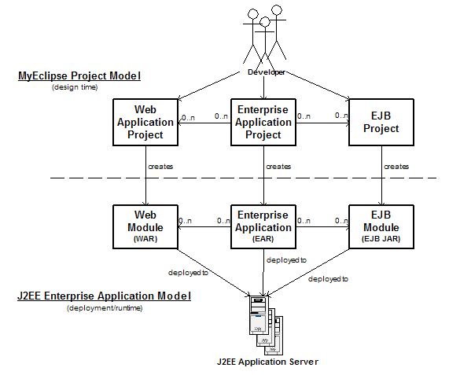

**Development Logic Behind J2EE Web Application**

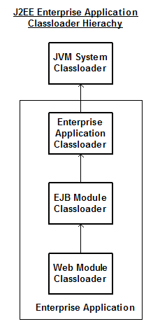

**Class Loader Hierarchy**

* 1. **Database Schema**

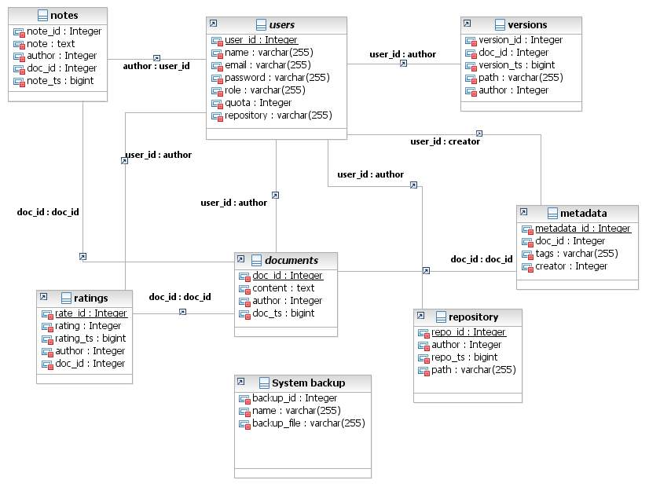

* 1. **Assumptions & Dependencies**
* Limited Document Editing Support
* More emphasis on document flow versioning and auditing

|  |
| --- |
| 1. Specific Requirements |

* 1. **Use Case Reports**
* **CHEIF**

The Chief is responsible for managing agents, managing cases, archiving cases , accessing database logs and creating digital signatures.

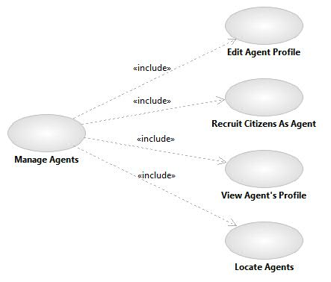

* **Manage Agents**

The Chief can manage Agents by selecting an recruiting citizens as agents , viewing agent’s profile , editing agent’s profile , locating agent by his last login ip address.

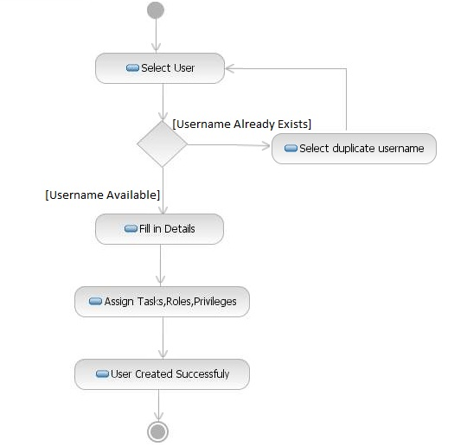

|  |  |
| --- | --- |
| **Name of use case** | Edit Agent’s Profile |
| **Description** | To edit an Agent’s profile (i.e. modifying those attributes that the agency/chief controls). |
| **Preconditions** | * Chief is already logged in. * Agent is an affiliated member of the agency. |
| **Normal flow of events** | * Edited information will be checked. * Query will be submitted. |
| **Alternate flow of events** | * Chief will be asked to refill the information if the submitted data doesn’t complies with the standards. |
| **Post Condition** | Agent’s profile successfully edited. |

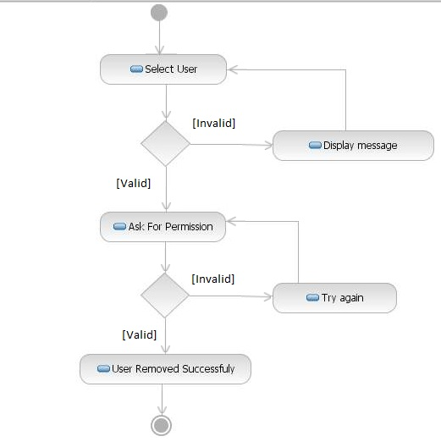

|  |  |
| --- | --- |
| **Name of use case** | Recruit Citizens as Agents |
| **Description** | To recruit a citizen as an agent on the basis of his/her profile and submitted form. |
| **Preconditions** | * Chief is already logged in. * The citizen as submitted the form with authentic information . |
| **Normal flow of events** | * Select the citizen. * Go through his/her profile and submitted form. * Recruit the citizen as an agent with a rank. * Query will be submitted. |
| **Alternate flow of events** | * Select another citizen. * Error displayed. |
| **Post Condition** | Citizen Recruited. |

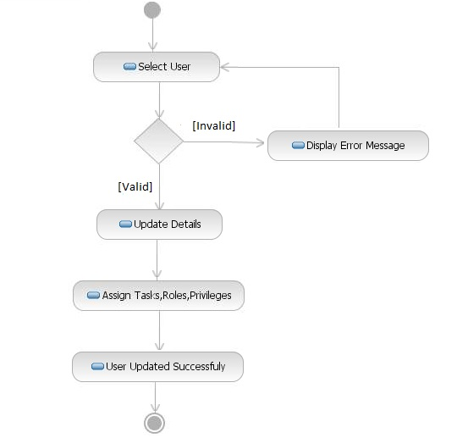

|  |  |
| --- | --- |
| **Name of use case** | View Agent’s Profile |
| **Description** | The Chief will just view an agents profile. |
| **Preconditions** | * Chief is already logged in. * The agent is an affiliated member of the agency. |
| **Normal flow of events** | * Select the agent. * Query will be submitted. |
| **Alternate flow of events** | * Error displayed. |
| **Post Condition** | Agent’s profile displayed. |



|  |  |
| --- | --- |
| **Name of use case** | Locate Agent |
| **Description** | The Chief will be able to locate the agent depending on agent’s last login ip address. |
| **Preconditions** | * Chief is already logged in. * The agent is an affiliated member of the agency. * The agent has at least logged in once into his account. |
| **Normal flow of events** | * Select the agent. * Query will be submitted. |
| **Alternate flow of events** | * Error displayed. |
| **Post Condition** | Agent located. |

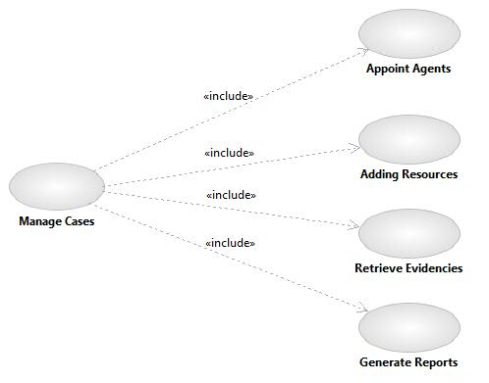

* **Manage Cases**

The Chief is responsible for appointing an agent to a case, adding resources, retrieving evidences and generating reports.

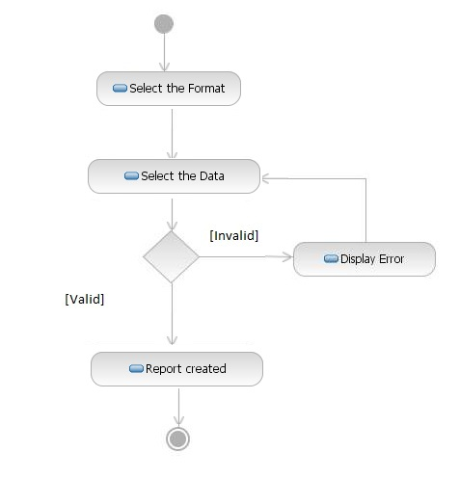

|  |  |
| --- | --- |
| **Name of use case** | Appoint Agents |
| **Description** | To appoint an agent for a particular case . |
| **Preconditions** | * Chief is already logged in. * The agent is an affiliated member of the agency. |
| **Normal flow of events** | * Select the agent and the case. * Query will be submitted. * Agent accepts. |
| **Alternate flow of events** | * Choose another agent. * Error displayed. |
| **Post Condition** | Case Assigned. |

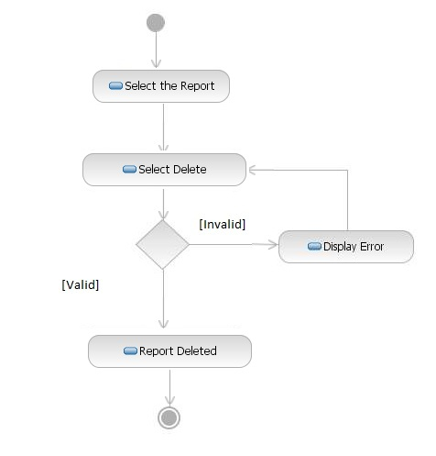

|  |  |
| --- | --- |
| **Name of use case** | Add Resources |
| **Description** | Adding resources to a particular case which may assist the agent in solving the case. |
| **Preconditions** | * Chief is already logged in. * Case is already assigned to an agent. |
| **Normal flow of events** | * Select the case. * Add resource to the case in concern. * Query will be submitted. |
| **Alternate flow of events** | * Assign the case to an agent. * Error displayed. |
| **Post Condition** | Resource added. |

|  |  |
| --- | --- |
| **Name of use case** | Retrieve Evidence |
| **Description** | Retrieve the encrypted evidence from the agent for the case. |
| **Preconditions** | * Chief is already logged in. * Case is already assigned to an agent. |
| **Normal flow of events** | * Select date. * Select submitted evidence if any. * Download & Decrypt. |
| **Alternate flow of events** | * Select another date. * Error displayed. |
| **Post Condition** | Resource added. |

|  |  |
| --- | --- |
| **Name of use case** | Generate Reports |
| **Description** | Generate reports for any case in general depending on its progress, evidences obtained and culprits identified. |
| **Preconditions** | * Chief is already logged in. * Case is already assigned to an agent. |
| **Normal flow of events** | * Get case progression. * Get evidence if any. * Send query for report generation. |
| **Alternate flow of events** | * Appoint an agent to the case. * Error displayed. |
| **Post Condition** | Report generated. |

|  |  |
| --- | --- |
| **Name of use case** | Archive Cases |
| **Description** | The Chief can store any case solved or unsolved in database , date them and save supporting evidences |
| **Preconditions** | * Chief is already logged in. * Case is/was assigned to an agent * Case had some progress. |
| **Normal flow of events** | * Get case. * Get evidence if any. * Get progress and useful leads. * Save case. |
| **Alternate flow of events** | * Get another case. * Error displayed. |
| **Post Condition** | Case Archived. |

|  |  |
| --- | --- |
| **Name of use case** | Create Digital Signatures |
| **Description** | The Chief can create digital signatures for any document which he intends to send so to maintain authenticity. |
| **Preconditions** | * Chief is already logged in. * Document being sent is not empty. |
| **Normal flow of events** | * Select any document. * Create digital signature. * Send document to people concerned |
| **Alternate flow of events** | * Error displayed. |
| **Post Condition** | Document with digital signature sent. |

* **Manage System**

Manage the creation and removal of regular backups of the system. He is also responsible for recovering system state when demanded.

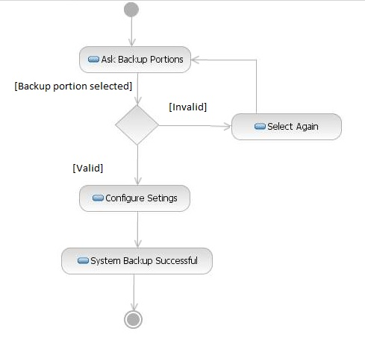

|  |  |
| --- | --- |
| **Name of use case** | Create Backup |
| **Description** | To create system backups |
| **Preconditions** | * Administrator is already logged in. |
| **Normal flow of events** | * Select the backup granularity. * Configure settings. * Query will be submitted. |
| **Alternate flow of events** | * Error displayed. |
| **Post Condition** | Backup created. |

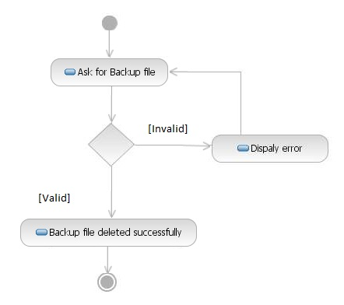

|  |  |
| --- | --- |
| **Name of use case** | Delete Backup |
| **Description** | To remove system backups |
| **Preconditions** | * Administrator is already logged in. * The backups have already been created. |
| **Normal flow of events** | * Select the backup. * Query will be submitted. |
| **Alternate flow of events** | * Error displayed. |
| **Post Condition** | Backup removed. |

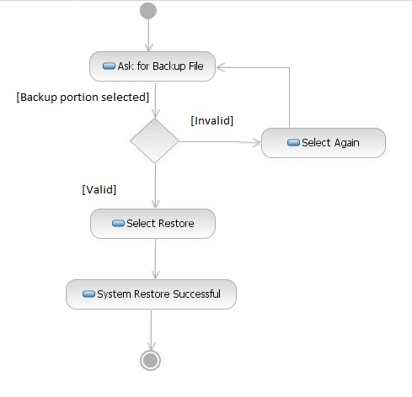

|  |  |
| --- | --- |
| **Name of use case** | Restore Backup |
| **Description** | To restore system using backup |
| **Preconditions** | * Administrator is already logged in. * The backups are available. |
| **Normal flow of events** | * Select the backup. * Configure restore options. * Query will be submitted. |
| **Alternate flow of events** | * Error displayed. |
| **Post Condition** | System restored. |

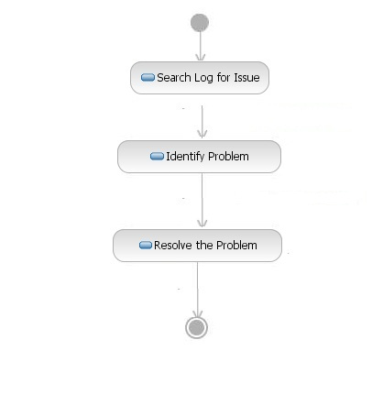

|  |  |
| --- | --- |
| **Name of use case** | Resolve Issues |
| **Description** | To resolve issues in the system |
| **Preconditions** | * Administrator is already logged in. * The system logs are available. |
| **Normal flow of events** | * Search logs for issues. * Identify problem. * Resolve the problem. |
| **Alternate flow of events** | * Error displayed. |
| **Post Condition** | Issues resolved. |

* **AGENT**

The Agent has functions and capabilities like managing cases, managing profile and ability to view map.

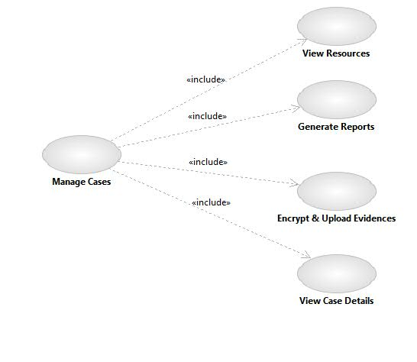

* **Manage Cases**

The Agent will have cases assigned to him by the chief which he can either accept or deny, view case details , view resources , generate reports and encrypt & upload evidences.

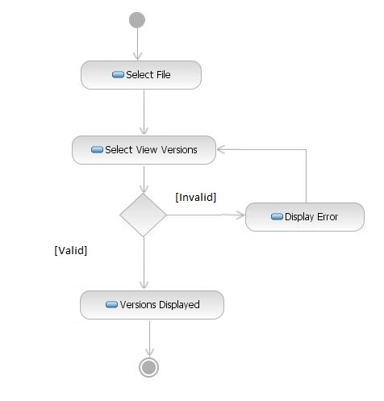

|  |  |
| --- | --- |
| **Name of use case** | View Case Assigned |
| **Description** | To accept or deny the case assigned to him and view related details |
| **Preconditions** | * Agent is already logged in. |
| **Normal flow of events** | * Select the case. * If accepted , check the details. * Case info acquired. |
| **Alternate flow of events** | * Deny the case with appropriate reasons. * Choose another case. |
| **Post Condition** | Case Checked. |

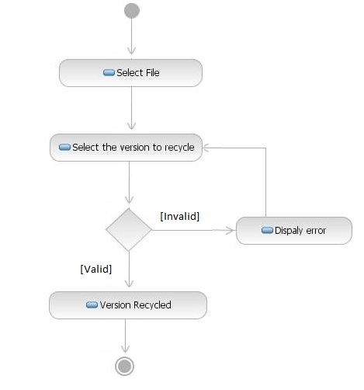

|  |  |
| --- | --- |
| **Name of use case** | Acquire Resources |
| **Description** | To get the resource related to case he’s working on. |
| **Preconditions** | * Agent is already logged in. |
| **Normal flow of events** | * Select the case. * Get the resource given by chief & ministry. |
| **Alternate flow of events** | * Display Error. |
| **Post Condition** | Case resource acquired. |

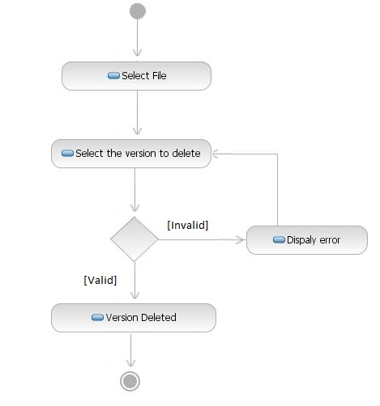

|  |  |
| --- | --- |
| **Name of use case** | Generate Reports |
| **Description** | Generating reports related to a case. |
| **Preconditions** | * Agent is already logged in. |
| **Normal flow of events** | * Select the case. * Generate report depending on the progress made. * Submit report. |
| **Alternate flow of events** | * Error displayed. |
| **Post Condition** | Report submitted. |

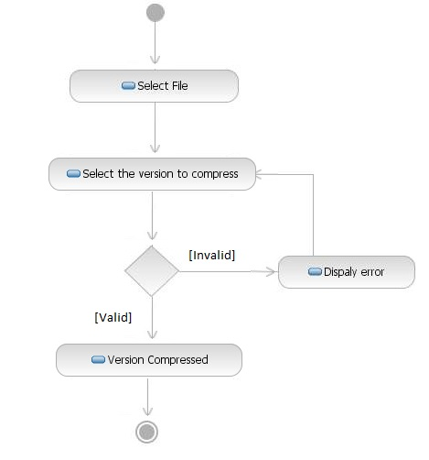

|  |  |
| --- | --- |
| **Name of use case** | Encrypt & Upload Evidences |
| **Description** | To encrypt an evidence so that its safe and can only be viewed by the chief and upload it to the database. |
| **Preconditions** | * Agent is already logged in. |
| **Normal flow of events** | * Select Case. * Compile the evidences related to the case. * Encypt the evidence with some private key,public key is with the chief. * Upload the dated evidence in the database. |
| **Alternate flow of events** | * Error displayed. |
| **Post Condition** | Evidence Uploaded. |

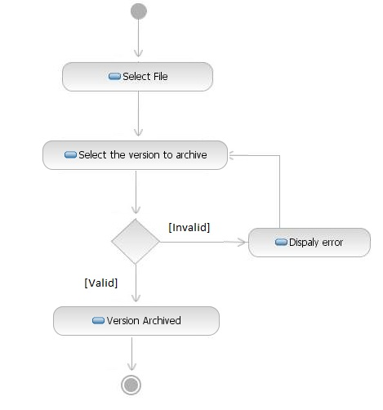

|  |  |
| --- | --- |
| **Name of use case** | View Map |
| **Description** | To be able to view the dynamic map and other associated functions. |
| **Preconditions** | * Agent is already logged in. |
| **Normal flow of events** | * View the map. * View location. * Perform related fucntions. |
| **Alternate flow of events** | * Error displayed. |
| **Post Condition** | Map Viewed. |

|  |  |
| --- | --- |
| **Name of use case** | Manage Profile |
| **Description** | To be able to view and manage profile but not thoses attributed managed by the chief. |
| **Preconditions** | * Agent is already logged in. |
| **Normal flow of events** | * Select the field. * Edit the concerned field. |
| **Alternate flow of events** | * If field not modifialble select another field. |
| **Post Condition** | Profile managed. |

* **MINISTRY**

The Ministry is responsible for managing cases and ministries intelligence wing can chat with the citizens.

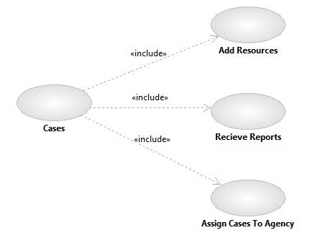

* **Manage Cases**

The Chief can manage cases by assigning cases to agency , providing the agency with supporting resources and recieving reports .

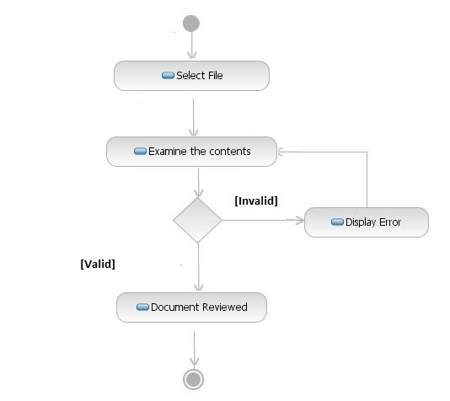

|  |  |
| --- | --- |
| **Name of use case** | Assign Cases To Agency |
| **Description** | Select a case from among the cases and forward it to the agency so that it may get required leads. |
| **Preconditions** | * Minister is already logged in. * Has available unsolved cases. |
| **Normal flow of events** | * Select a case. * Assign the case to agency. * Case forwarded. |
| **Alternate flow of events** | * Error displayed. |
| **Post Condition** | Cases Assigned To Agency. |

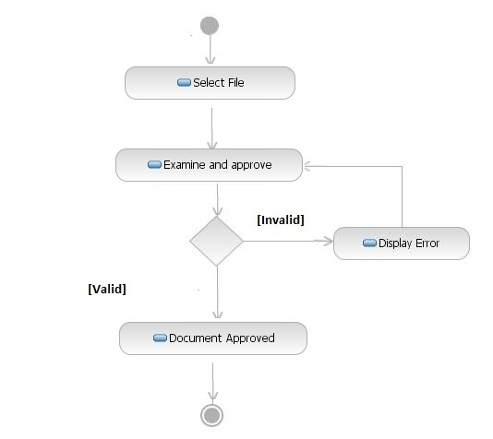

|  |  |
| --- | --- |
| **Name of use case** | Retrieve Reports |
| **Description** | The Minister is able to retrieve reports for any case. |
| **Preconditions** | * Minister is logged in . * The case has been assigned to the agency. |
| **Normal flow of events** | * Select the case. * If has available reports retrieve the reports. * Reports retrieved. |
| **Alternate flow of events** | * If case not yet assigned , assign it to the agency. * If no reports available , inquire the chief about the delay. |
| **Post Condition** | Report Retrieved. |

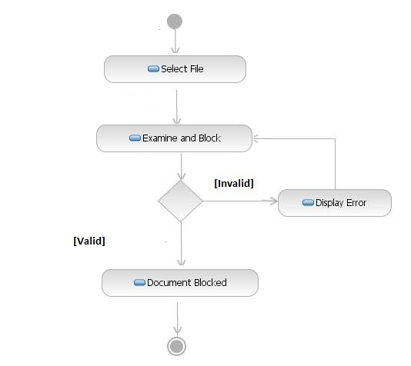

|  |  |
| --- | --- |
| **Name of use case** | Add Resources |
| **Description** | The Minister can add resources related to a case. |
| **Preconditions** | * Minister is already logged in. * Case is already assigned to the agency. |
| **Normal flow of events** | * Select the case. * Add supportive resources. |
| **Alternate flow of events** | * Assign the case to the agency. |
| **Post Condition** | Resource Added. |

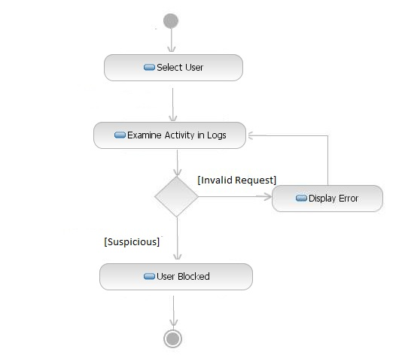

|  |  |
| --- | --- |
| **Name of use case** | Citizen Suggestion and Informations |
| **Description** | To be able to monitor citizens suggestions, tips and informations and publish or incorporate if found useful. |
| **Preconditions** | * Member of intelligence wing is logged in. |
| **Normal flow of events** | * Select a citizen by name. * Go through his/her suggestions. * Publish suggestions . |
| **Alternate flow of events** | * If confidential information provided then pass it to ministry . * Keep the identity of the citizen a secret. |
| **Post Condition** | Managed the Citizen’s involvement. |

|  |  |
| --- | --- |
| **Name of use case** | Chatting Facility |
| **Description** | To have the facility to chat with the citizen. |
| **Preconditions** | * Member of intelligence wing is logged in. |
| **Normal flow of events** | * Recieve the chat request by a citizen. * Record the chat , ip address & citizen’s name for security purposes. |
| **Alternate flow of events** | * Error Displayed. |
| **Post Condition** | Chatting Done. |

* **CITIZEN**

The Consumer is client user of the system. He shall be collaborating and sharing documents, as a part of his business requirements, using the system.

* **Apply For Agent**

A Citizen can apply for the post of an agent in a secret manner such that only the secret agency would know of the request and the application.

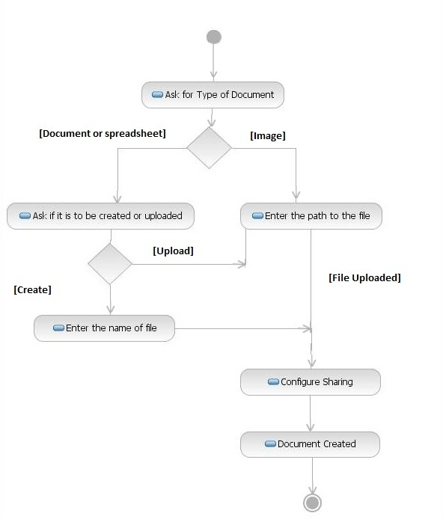

|  |  |
| --- | --- |
| **Name of use case** | Apply For Agent. |
| **Description** | To be able to apply by filling a form for the post of agent if meets all the prerequisites. |
| **Preconditions** | * Meets the requirements. |
| **Normal flow of events** | * Select the the application module. * Fill the form. * Attach the related documents. * Application submitted. |
| **Alternate flow of events** | * Not elligible for the application. |
| **Post Condition** | Applied Successfully. |

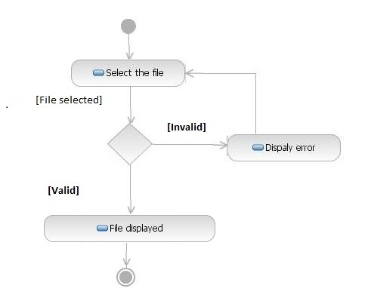

|  |  |
| --- | --- |
| **Name of use case** | Give Suggestions |
| **Description** | A Citizen should be able to suggest , provide tips and other informations to the intelligence wing of the ministry. |
| **Preconditions** | * No preconditions. |
| **Normal flow of events** | * Give suggestion. * Declare whether wants the name to be published or identity to be maintained a secret. |
| **Alternate flow of events** | * Error displayed. |
| **Post Condition** | Suggestion and informations submitted. |

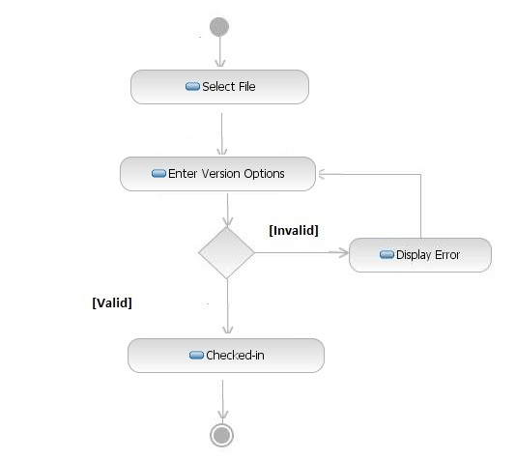

|  |  |
| --- | --- |
| **Name of use case** | Chatting facility |
| **Description** | To be able to Chat with the Intelligence wing of the ministry. |
| **Preconditions** | * No preconditions. |
| **Normal flow of events** | * Send a chat request. * Recieve the time for the chat . * Chat. |
| **Alternate flow of events** | * Error displayed. |
| **Post Condition** | Chatting Done. |

* 1. **Supplementary Requirements**
* **Have hours of operation that are 24 x 7** - Because system can be an automated process, so it can stay open for 24 hours a day. If the base is now the entire world, staying open 24 hours a day becomes critical. System is required to be available 24X7 so UPS support must be on server site for at least 8 hours in case of power failure. System will remain inaccessible to users at 2:00 to 4:00 am for backup and maintenance purpose.
* **Make the existing Web site more dynamic in nature** - Many early Web implementations consisted of static HTML pages. This becomes very difficult to manage if the number of pages gets too large. An effective system should be largely dynamic taking advantage of technology that automates this process rather than relying on manual processes. Application should serve dynamic user based customized web pages to its clients from server.
* **Tie the existing Web site into existing enterprise systems** – Any existing Web site that relies on the manual duplication of data from another system is one that can be improved. Most of the business data in the world today exists in enterprise servers that can be connected to the Web servers to make this process far more effective.
* **Provide good performance and the ability to scale the server** – The Web Application Server should provide good performance and the ability to manage performance with techniques, such as support for caching, clustering, and load balancing.
* **Providing session management capability** - Web application developers should not spend valuable time worrying about how to maintain sessions within the application. The Web Application Server should provide these services.

|  |
| --- |
| 1. Appendices |

* 1. **Acknowledgments**

We would like to convey our deep sense of gratitude to our department and our institute for guidance and support. Special thanks to our project guide for all encouragement and motivation to successfully submit the SRS.